University of Plymouth

**SOFT252:**Object-oriented Software Engineering

with Design Patterns

User manual

*Student number: 10576156*

Word count

Report:  907

January 16th, 2019

**Instruction comments:**

For the purposes of creating first account, the root administrator account was created. The ID number is: “A0000”, and the password is: “root”. **It is important to mention that an element of Swingx was used, namely JXDatePicker.** **The NetBeans might ask for swingx-all-1.6.4 file which is provided in main submission folder.**

**Available accounts:**

**Type Name ID Number Password**

Secretary Lauren Farrell S0001 lfarrell

Doctor Benjamin Coleman D0002 bcoleman

Doctor Ava Tucker D0003 atucker

Doctor Lydia Reed D0004 lreed

Administrator Alex Howell A0005 ahowell

Patient Ethan Law P0006 elaw

Patient Katie Barrett P0007 kbarrett

Patient Aimee Mellor P0008 amellor

**User Manual:**

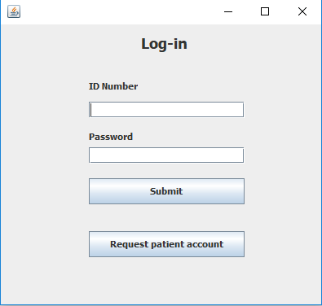The user manual will provide overview on how to use most important of the functionalities in the program.

Figure Login screen

First screen that is presented to user is the login menu from where the user can log in into their account or request a new patient account. If the latter is chosen, they are presented with the form to provide information and a button to request the account. It is necessary to provide all the information as the request will not be created otherwise.

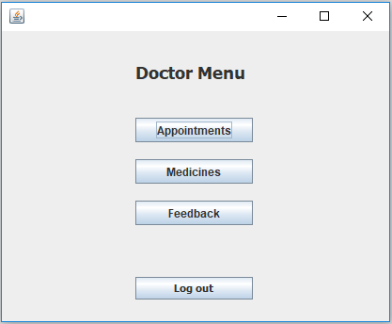After successfully logging in, the user is presented with main navigation menu, which is different for every account type. Example account menu is presented on Figure 2.

Figure Doctor navigation menu

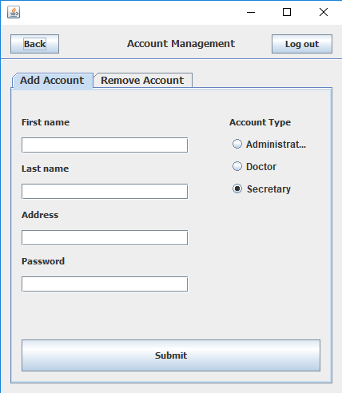

Figure Administrator - add / remove account

One of the most important functionalities is account management of the Administrator. To add the account, the administrator has to fill out the form and submit the information. In the next tab, they can remove the accounts by selecting one and clicking “Remove the account” button. It is worth noting that every screen has an option to navigate around application by either going back or logging out.

As for Secretary account management, they can approve and terminate patients accounts on their request. A screenshot of the menu to do these functionalities is provided on Figure 4. The Secretary has to select the request from the list, highlighting it and pressing the button, which in turn fills out the information about the Patient on the right side. Next, Secretary can verify (or Terminate) the account using the button under the patient’s details.

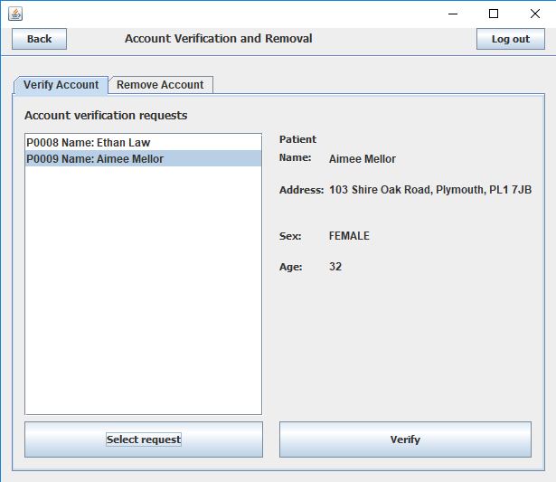

Figure 4 Secretary - account verification / removal

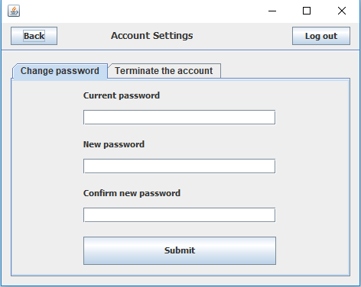From the patients’ side of view, the account management allows them to change password or request the account termination. The patient has to provide the current password before they make any of these changes.

Figure Patient's account settings

The patient can also write the review of the doctor. They can do that by highlighting the doctor in the list and selecting by the use of the button underneath. After that, the reviews menu is updated and comments, average rating are displayed. User can provide their own information by selecting “Write review” tab, filling out the text area, selecting rating score and submitting it using the button.

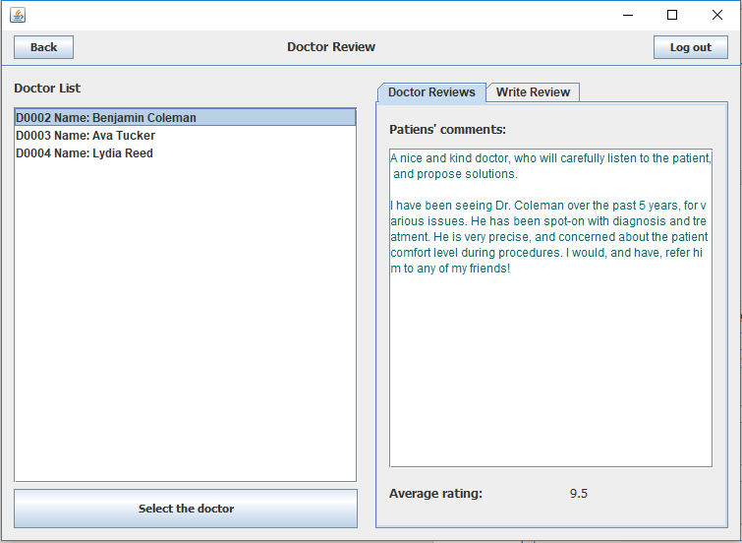

Figure 6 Patient - providing doctor review

The patient can also request the appointment with one of the doctors. It is done by highlighting the doctor, selecting the date and time and clicking “Request an Appointment” button.

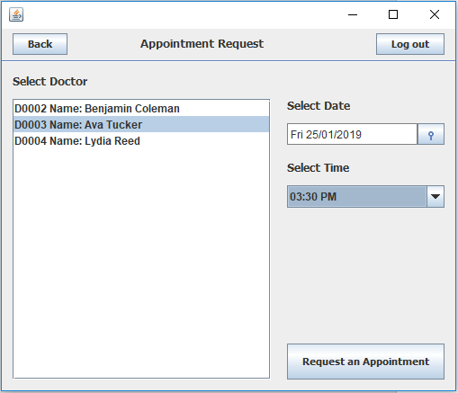

Figure 7 Patient - appointment request

As for the appointments, the Secretary can either approve or remove them from the list. It is done again, by highlighting specific appointment and clicking on one of the buttons.

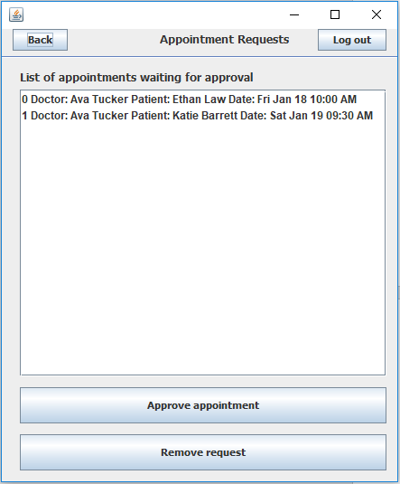

Figure 8 Secretary - appointment approval / removal

The Secretary can also create new appointment between doctor and patient. It is done by highlighting both doctor and patient from the lists, as well as selecting the date and time from the UI elements underneath.

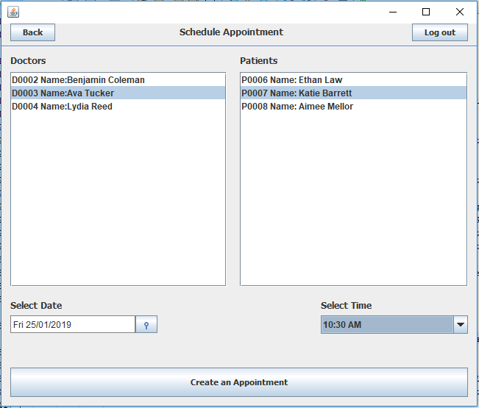

Figure 9 Secretary - Appointment creation

Another one of Secretary functionalities is ordering the medicine. Secretary can order it by highlighting the medicine order request on the right side of the screen and clicking “Order medicine” button.

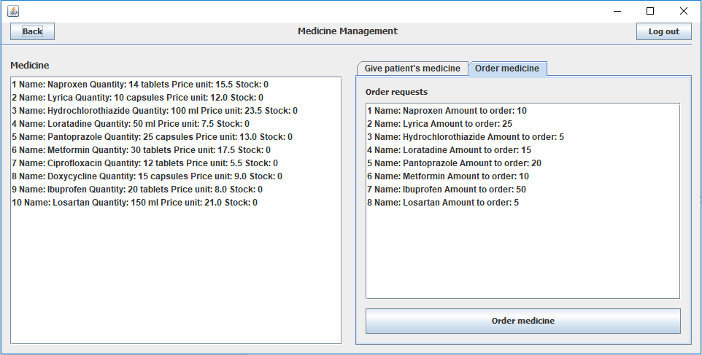

Figure 10 Secretary - Medicine order

As for the doctor functionalities, they can see the scheduled appointments in the “Appointments” menu, from which they can access patient history or start the appointment. It is necessary to highlight one of the entries in the list first.

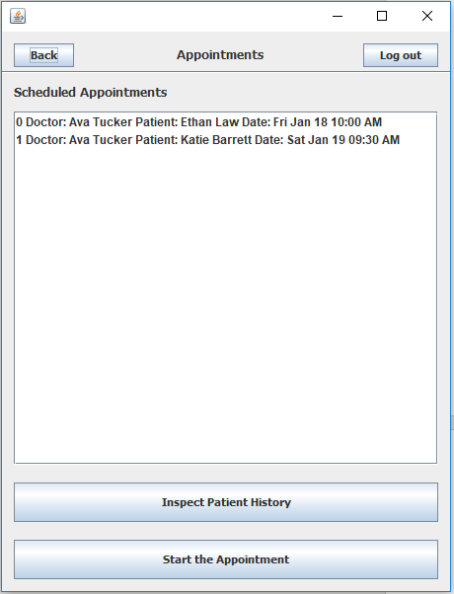

Figure 11 Doctor - Scheduled appointments menu

After inspecting patient’s history, the doctor is presented with the menu on the following figure. They can then highlight and select one of the appointments which in turn fills out the data on right side of the screen.

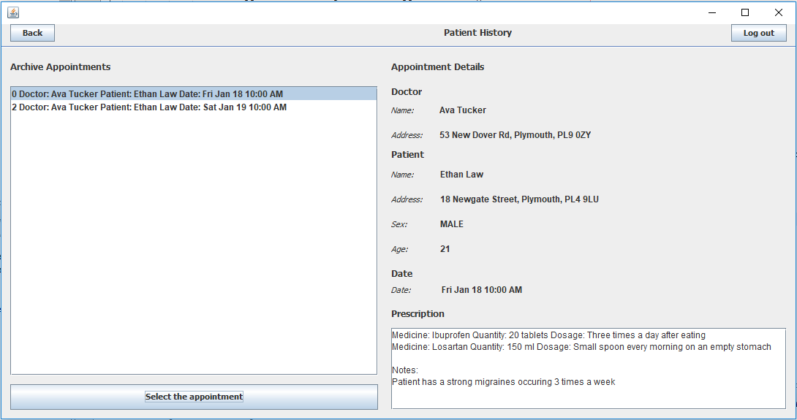

Figure 12 Doctor - Patient history inspection

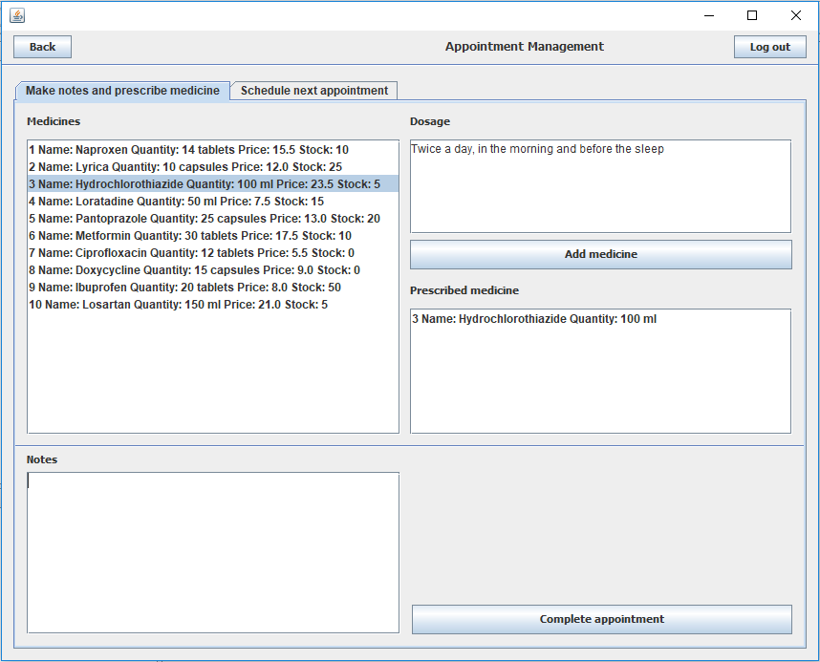

Figure 13 Doctor - During the appointment

As can be seen on the Figure 13, the Doctor can prescribe the medicine for the patient by highlighting the medicine and providing information about dosage and finally, clicking “Add medicine button”. It is also possible to provide additional notes. The appointment is submitted when Doctor clicks on “Complete appointment” button. After that, the data about appointment is saved and the appointment is processed.

The doctor can also add the medicine by providing its name, description, type, quantity and price. The amount in stock is automatically set to zero. After that, the medicine can be ordered from the tab named “Request medicine order” where doctor selects the medicine from the list and provides the amount to order. Later the Secretary can process the order.

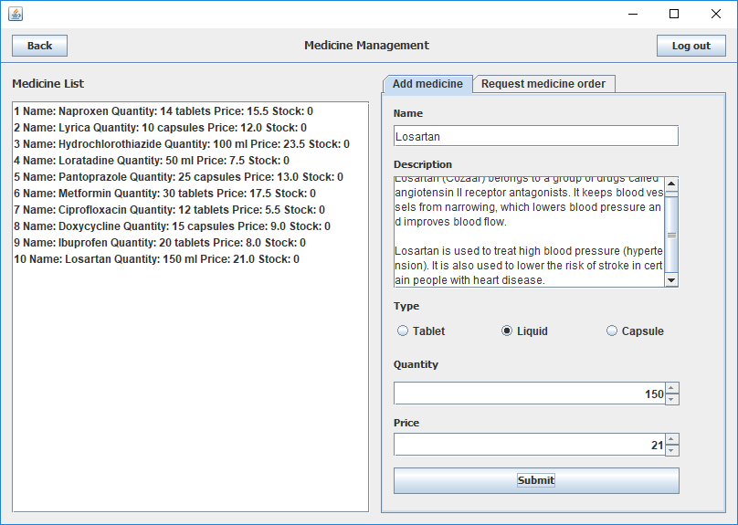

Figure 14 Doctor - Adding new medicine

Finally, after Secretary or Doctor creates the appointment, the Patient is informed with the message after logging in, and they can access more information from the Appointment menu.

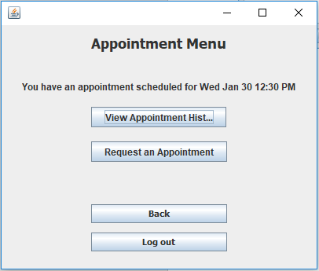

Figure 15 Patient - Scheduled meeting